INSTITUITONAL ETHICS COMMITTEE
LADY HARDINGE MEDICAL COLLEGE & ASSOCIATED HOSPITALS, NEW DELHI

Form for Forwarding the Research Protocols by Head of the Department

To,
The Member Secretary,
Institutional Ethics Committee
LHMC & Associated Hospitals
New Delhi

Title of the Project: _____________________________________________________________
Principal Investigator: ___________________________________________________________
Date of submission by PI to HOD: _________________________________________________
I have gone through the Protocol along with Annexures submitted by PI for consideration of IEC and have following comments to offer:

1 | Whether routine patient care would be compromised as a result of this project? | Yes/ No /NA
2 | Whether functioning of the department would be adversely affected? | Yes/ No /NA
3 | Would the project lead to improvement in the skills of faculty/staff of the Department | Yes/ No /NA
4 | Whether PI/Co-PI has adequate capacity to undertake the Project? | Yes/ No /NA
5 | Whether facilities and/or equipment available in the Department would be made available to PI and his team? | Yes/ No /NA
6 | Any other comment on the Project
7 | Number of on-going funded research projects by the PI
8 | Number of on-going non-funded research projects by the PI

Annnexure-1. Attach the list of the current funded and non-funded research projects by the PI.

The Proposal is forwarded and
(a) Recommended for approval by IEC
(b) Recommended subject to above comments
(c) Not-recommended due to following reasons:

Date Signature
(Name & Designation with seal)

Annnexure-1. The list of the current funded and non-funded research projects by the PI.

Name of the PI-
Department
Serial No. | Title of the project | Funded or Non-funded | Date of approval
1
2
3
4
5
6
7

INSTITUITONAL ETHICS COMMITTEE
LADY HARDINGE MEDICAL COLLEGE & ASSOCIATED HOSPITALS, NEW DELHI

Form to be filled by the Principal Investigator (PI) for submission to Institutional Ethics Committee
Please fill the form completely. Incomplete forms are liable to rejection.
Reference No. |  |  | To be entered by IEC)

Proposal Title:

 | Name, Designation  &  Qualifications | Address  Tel & Fax Nos. Email ID | Signature
PI
Co-PI /
Collaborators

1.
2.
3.
Please attach brief Curriculum Vitae of all Investigators (with subject specific publications limited to previous 5 years) and also the soft copy of the proposal and also the PPT and 2 hard copies. Also attach Plain Language Summary of the proposal.
Tick appropriately
Sponsor Information:
1. Indian a) Government Central State Institutional
b) Private
2. International Government Private UN agencies

3. Industry National Multinational

Name and Contact Address of Sponsor:

Total Budget:

- Does the budget reflect a) Institutional overheads Y/N Please give details__________________?
- Any payments / benefits to the investigators Y/N If Yes, Please give details______________
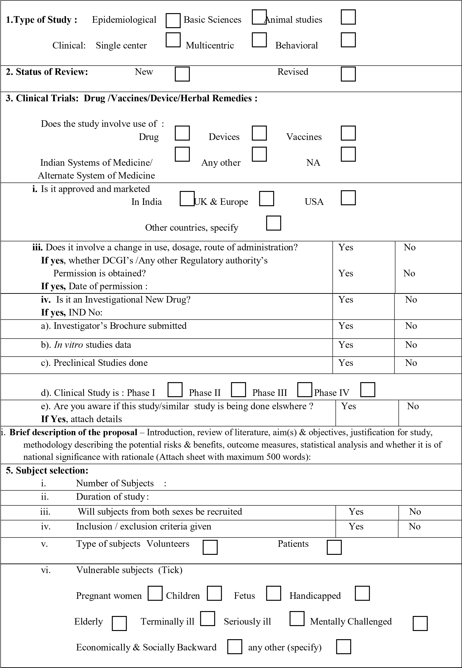

6. Privacy and confidentiality
i. Study involves - Direct Identifiers
Indirect Identifiers/coded
Completely anonymised/ delinked

ii. Confidential handling of data by staff |  |  | Yes | No
7. Use of biological/ hazardous materials  i. Use of fetal tissue or abortus |  |  | Yes | No
iii. Use of organs or body fluids |  |  | Yes | No
iii. Use of recombinant/gene therapy  If yes, has Department of Biotechnology (DBT) approval for rDNA products been obtained? |  |  | Yes  Yes | No  No
iv. Use of pre-existing/stored/left over samples |  |  | Yes | No
v. Collection for banking/future research |  |  | Yes | No
vi. Use of ionising radiation/radioisotopes  If yes, has Bhaba Atomic Research Centre (BARC) approval for Radioactive Isotopes been obtained? |  |  | Yes  Yes | No  No
vii. Use of Infectious/biohazardous specimens |  |  | Yes | No
viii. Proper disposal of material |  |  | Yes | No
ix. Will any sample collected from the patients be sent abroad? If Yes, justify with details of collaborators |  |  | Yes | No
a) Is the proposal being submitted for clearance from Health Ministry’s Screening Committee (HMSC) for International collaboration? |  |  | Yes | No
b) Sample will be sent abroad because (Tick appropriate box): If so, reasons… Facility not available in India Facility in India inaccessible
Facility available but not being accessed.
8. Consent: *Written Oral Audio-visual Consent form: (tick the included elements)
Understandable language Alternatives to participation
Statement that study involves research Confidentiality of records
Sponsor of study Contact information
Purpose and procedures Statement that consent is voluntary
Risks & Discomforts Right to withdraw
Benefits Consent for future use of biological material
Compensation for participation Benefits if any on future commercialization Compensation for study related injury
*If written consent is not obtained, give reasons:

ii. Who will obtain consent? PI/Co-PI Research staff |  | Nurse/Counsellor  Any other
9. Will any advertising be done for recruitment of Subjects?  (posters, flyers, brochure, websites – if so kindly attach a copy) |  |  | Yes | No
10. Risks & Benefits:  i. Is the risk reasonable compared to the anticipated benefits to subjects / community / country? |  |  | Yes |  | No
ii. Is there physical / social / psychological risk / discomfort? If Yes, Less than Minimal risk  Minimal Risk  Minor increase over minimal risk or Low risk  More than minor increase or High risk |  |  | Yes |  | No
iii.Is there a benefit a) to the subject? Direct Indirect b) Benefit to society
11. Data Monitoring  i. Is there a data & safety monitoring committee/ Board (DSMB) |  |  | Yes |  | No
ii. Is there a plan for reporting of adverse events? If Yes, reporting is done to:  Sponsor Ethics Committee DSMB |  |  | Yes |  | No
iii. Is there a plan for interim analysis of data? |  |  | Yes |  | No
vi. Are there plans for storage and maintenance of all trial databases? If Yes, for how long? |  |  | Yes |  | No
12. Is there compensation for participation?  If Yes, Monetary In kind  Specify amount and type: |  |  | Yes |  | No
13. Is there compensation for injury?  If Yes, by Sponsor by Investigator  by insurance company by any other |  |  | Yes |  | No
14. Do you have conflict of interest? (financial/nonfinancial)  If Yes, specify :  In case the investigator(s) are receiving any payment or direct benefit due to the project, it may be considered a conflict of interest and should be detailed here. NOTE: It shall be the responsibility of the investigator(s) to take  Appropriate administrative permissions for the pecuniary benefits a priori. |  |  | Yes  Noted |  | No
Checklist for attached documents: 4 consolidated copies of the following

Form 1, Form 2, Form 3
Project proposal
Patient information sheet in English and Hindi
Informed Consent form in English and Hindi
Investigator’s brochure for recruiting subjects
Curriculum Vitae of Investigators
Brief description of proposal
Copy of clinical trial protocol and/or questionnaire

Place: Signature & Designation of PI/Co-PI/Collaborator
Date:

NOTE: All the research protocols will undergo through pre-meeting review by the members and experts. This process will take 2-3 weeks.
UNDERTAKING BY THE INVESTIGATOR

1. Full name, address and title of the Principal Investigator (or Investigator(s) when there is no Principal Investigator)

2. Protocol Title and Study number (if any) of the clinical trial to be conducted by the Investigator.

3. Commitments:

(i) I have reviewed the clinical protocol and agree that it contains all the necessary information to conduct the study. I will not begin the study until all necessary Ethics Committee and regulatory approvals have been obtained.
(ii) I agree to conduct the study in accordance with the current protocol. I will not implement any deviation from or changes of the protocol without agreement by the Sponsor and prior review and documented approval I favourable opinion from the Ethics Committee of the amendment, except where necessary to eliminate an immediate hazard(s) to the trial Subjects or when the changers) involved are only logistical or administrative in nature.
(iii) I agree to personally conduct and/or supervise the clinical trial at my site.
(iv) I agree to inform all Subjects; that the drugs are being used for investigational purposes and I will ensure that the requirements relating to obtaining informed consent and ethics committee review and approval specified in the OCP guidelines are met.
(v) I agree to report to the 'Sponsor all adverse experiences that occur in the course of the investigation(s) in accordance with regulatory and GCP guidelines.
(vi) I have read and understood the information in the Investigator's brochure, including the potential risks and side effects of the drug.
(vii) I agree to ensure that all associates, colleagues and employees assisting in the conduct of the study are suitably qualified and experienced and they have been informed about their obligations in meeting their commitments in the trial.
(viii) I agree to maintain adequate and accurate records and to make those records available for audit / inspection by the Sponsor, Ethics Committee, Licensing Authority or their authorized representatives, in accordance with regulatory and OCP provisions. I will fully cooperate with any study related audit conducted by regulatory officials or authorized representatives of the Sponsor.
(ix) I agree to promptly report to the Ethics Committee all changes in the clinical trial activities and all unanticipated problems involving risks to human Subjects or others.
(x) I agree to inform all unexpected serious adverse events to the Sponsor as well as the Ethics Committee within 24 hours of their occurrence.
(xi) I will maintain confidentiality of the identification of all participating study patients and assure security and confidentiality of study data.
(xii) I agree to comply with all other requirements, guidelines and statutory obligations as applicable to clinical Investigators participating in clinical trials including the provisions contained in National Ethical Guidelines for Biomedical and Health Research involving Human Participant, 2017 by ICMR and The New Drugs and Clinical Trial Act, 2019.

Signature of Investigator with Date

